Smart Contract Guidelines

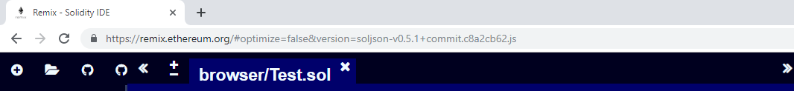

Go to the website <https://remix.ethereum.org/>

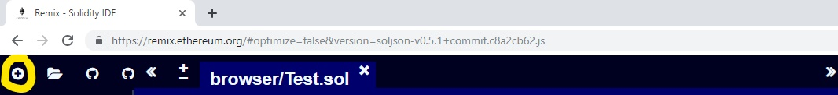

Click on add new Solidity file on the left side bar. Then name the file you create with extension “.sol”.

Then paste the contract code into the solidity file you just created.

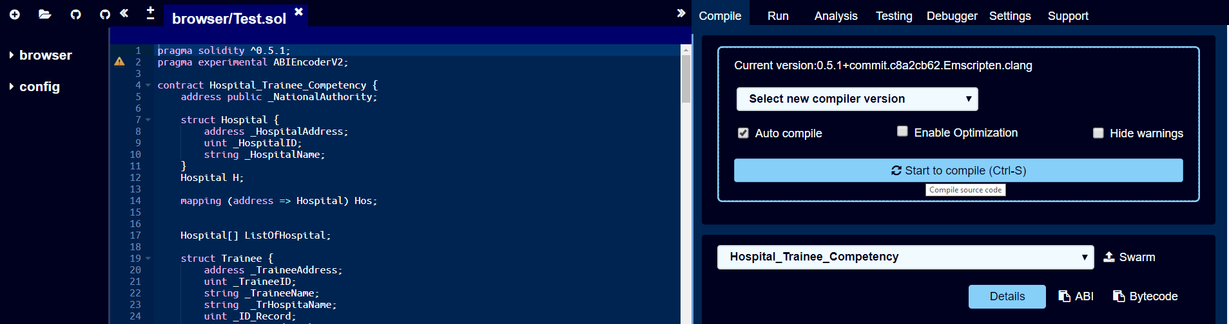

Click on “Start to compile (Ctrl+S)” to compile the code.

Then the name of the contract should pop up as the image above.

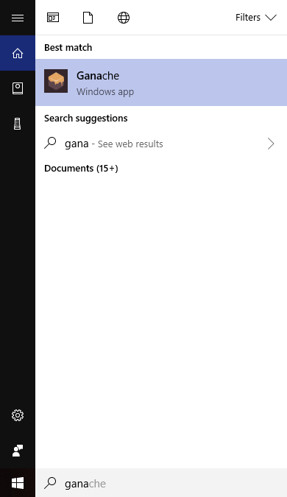

Now you need a blockchain testnet. Open Ganache (Blockchain Testnet) by searching it on your computer.

If you don’t have Ganache yet, you can download it for free at <https://truffleframework.com/ganache>

After finishing downloading Ganache into your computer, you can open it as described above.

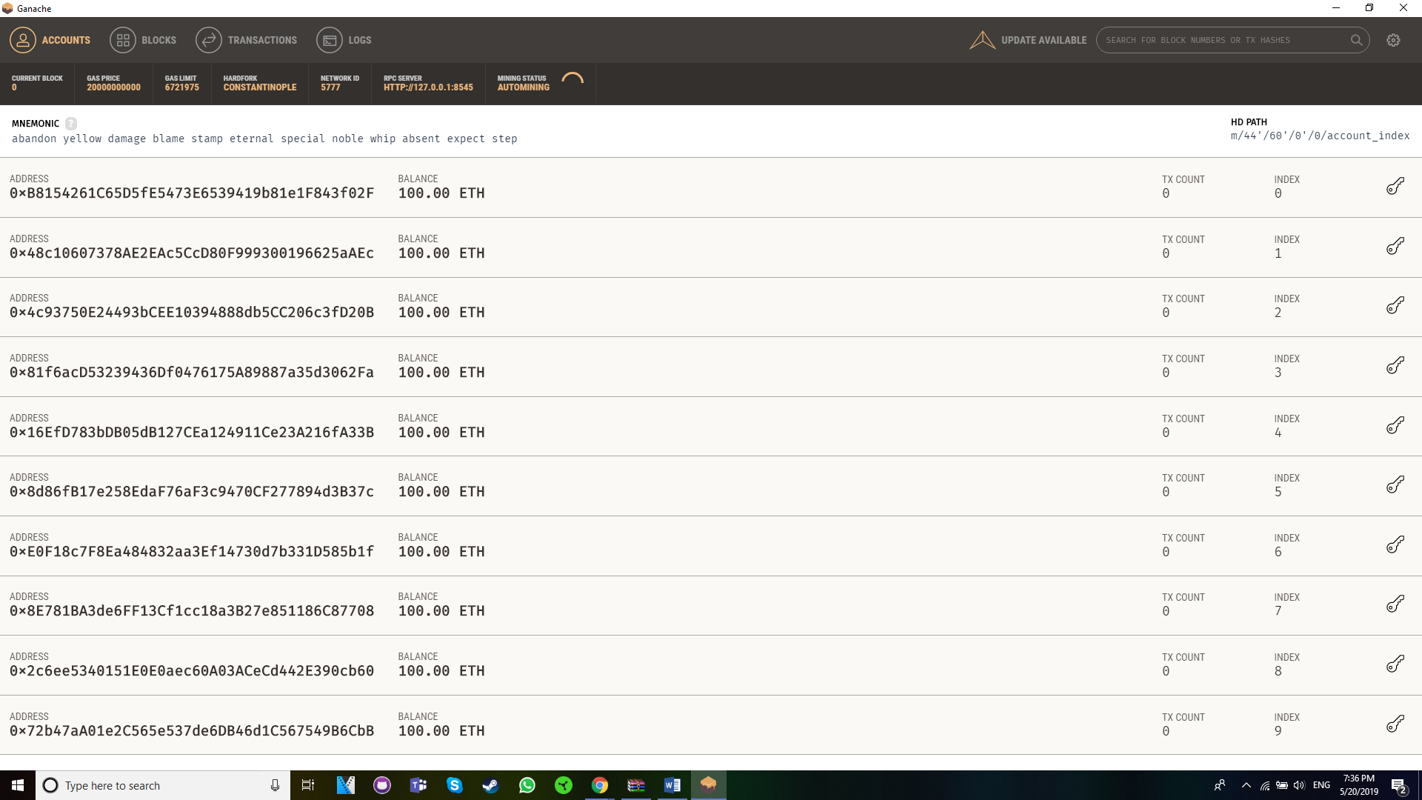

Here is the Ganache User Interface. It already provides 10 testing accounts.

Now back to the Remix Webpage.

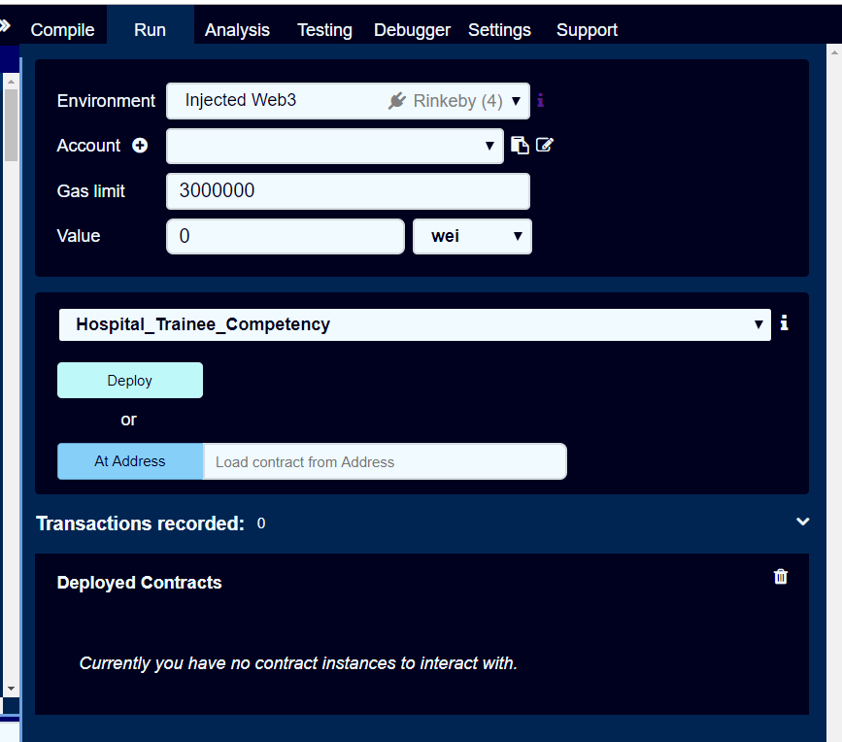

On the right side, the environment can be “JavaScript VM”, “Injected Web3”, “Web3 Provider”.

JavaScript VM : Used for local testing.

Injected Web3 : can be used for Ethereum Mainnet or Ethereum TestNet like Ropsten, Rinkeby,..

Web3 Provider : Used for private blockchain testnet.

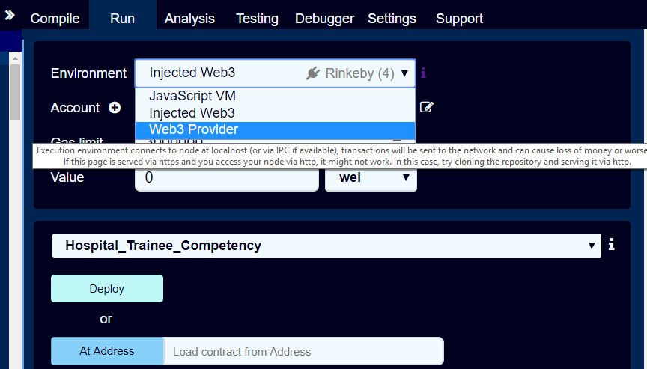

Now we need to run it on private testnet so click on the environment and choose “Web3 Provider”

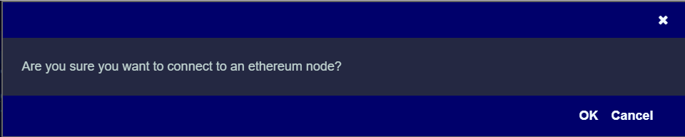

The page will pop up a message like this. Click on “OK” button.

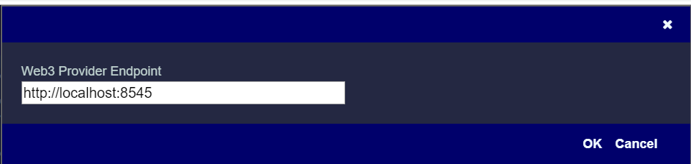

Check your port if it is match with Ganache port. If it doesn’t match, you can adjust the port. Then click on “OK” button.

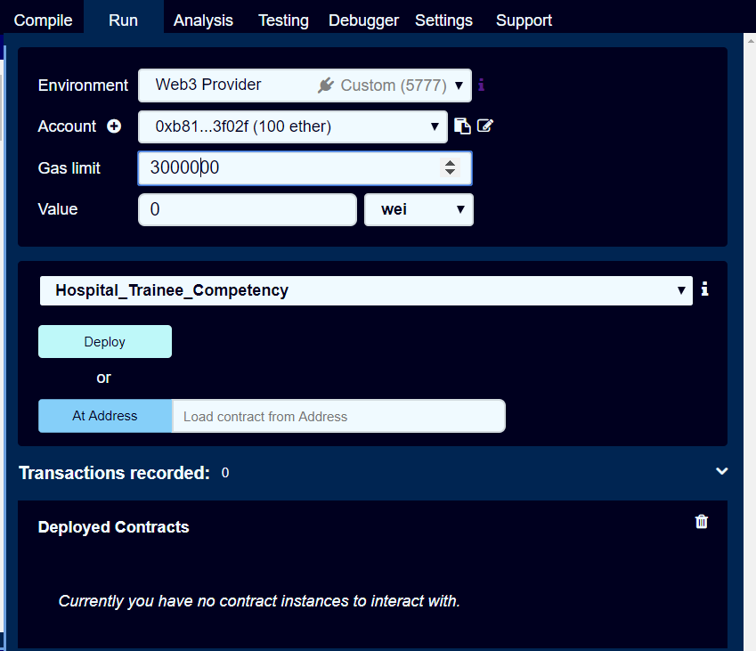

Now it should look like this. Then click on “Deploy” button to deploy your smart contract.

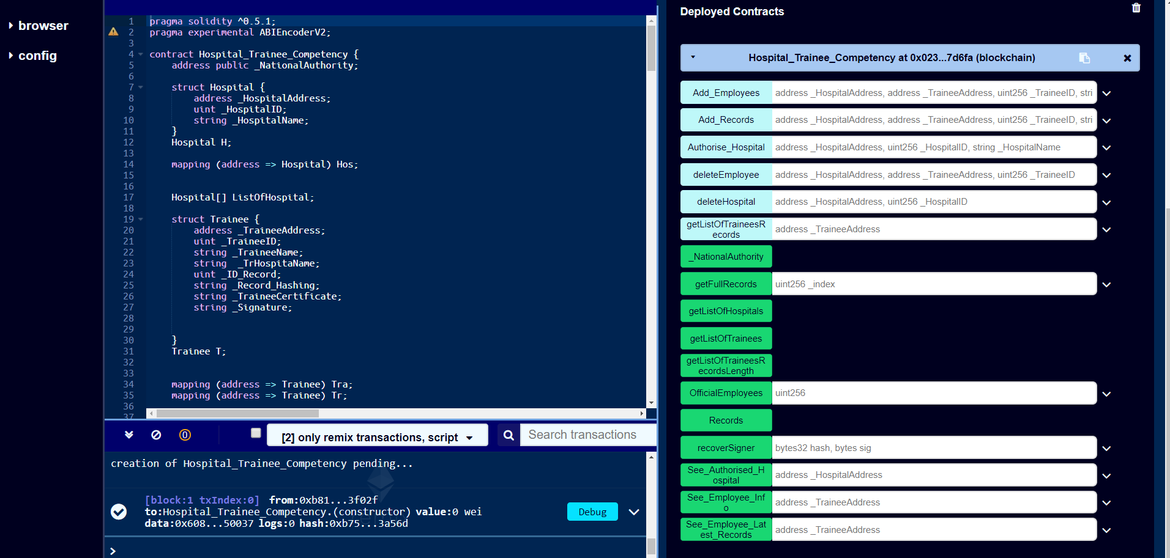

Now you can see your deployed contract and its functions on the right side.

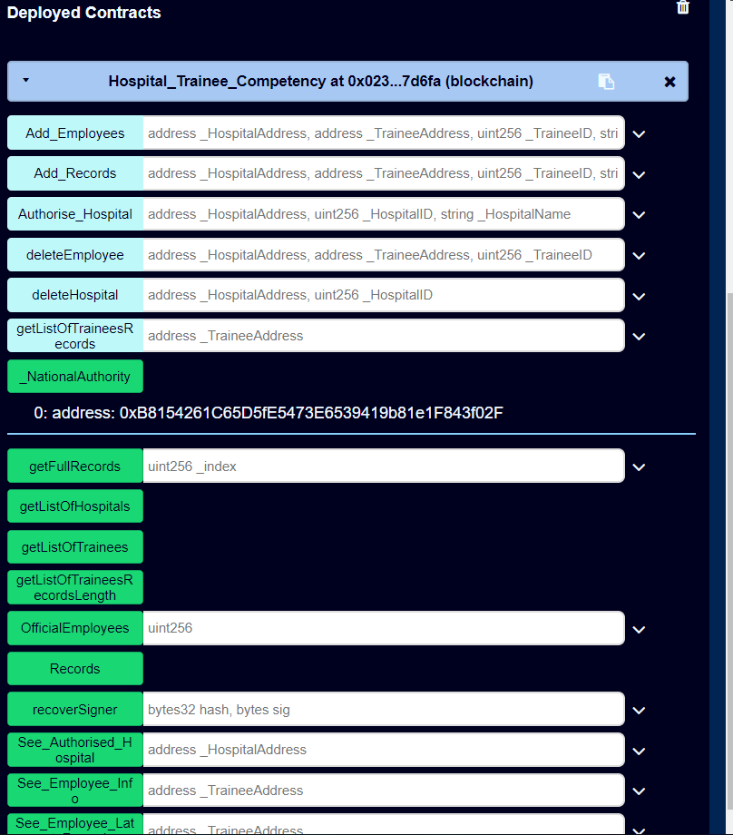

The National Authority is also the address of the account deploying the smart contract onto the private blockchain testnet. With the National Authority address, you can authorize other addresses to become authorized hospitals.

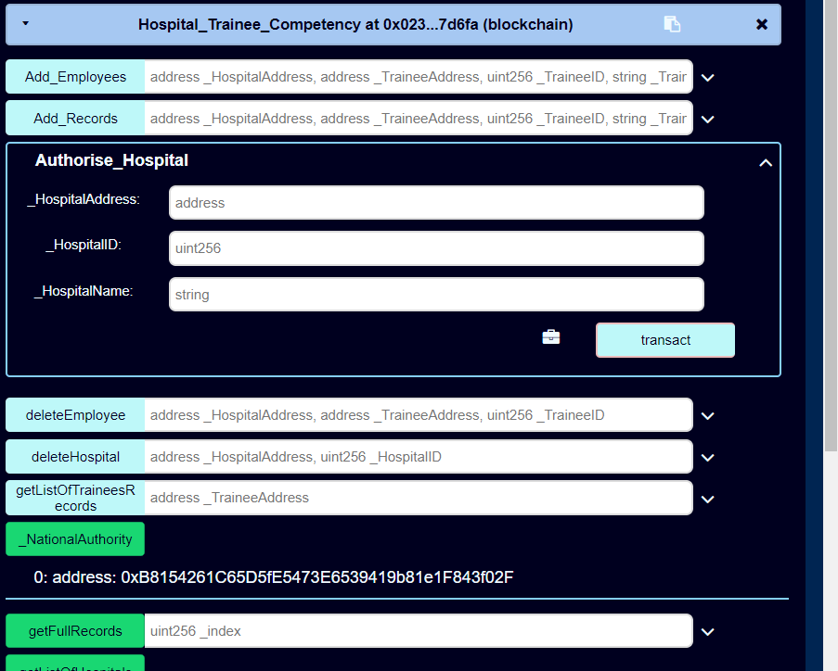

To authorize a new hospital, you need to fill in the address you wish to authorize and its ID, Name. Keep in this mind, these information should be unique and doesn’t exist in the smart contract storage.

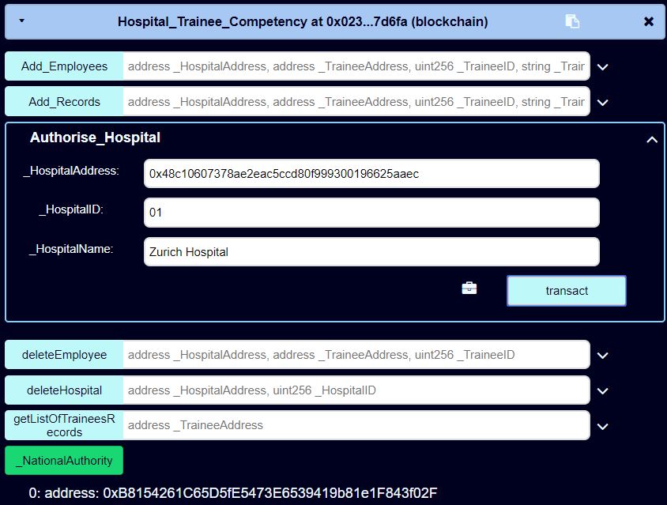

The information you fill in should look similar like this. If not, you can’t authorize hospitals as you wish. The click on “transact” button to authorize a new hospital.

Note : The address should be the National Authority address.

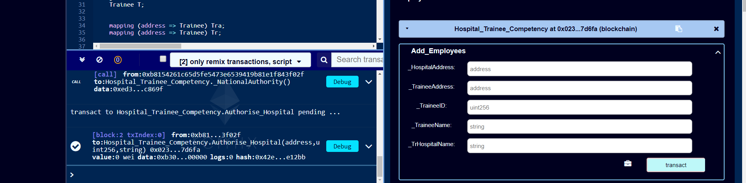

After authorizing successfully, a new block will be created and stored your filled data.

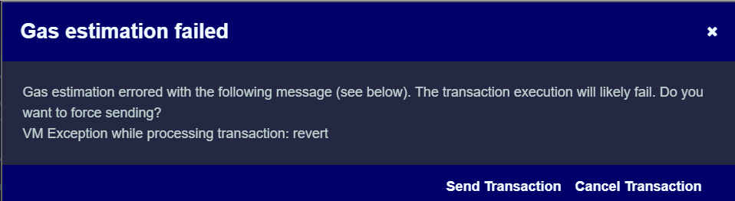

If this announcement pops up, it means you have failed to authorize a new hospital. Check the input again as it requires.

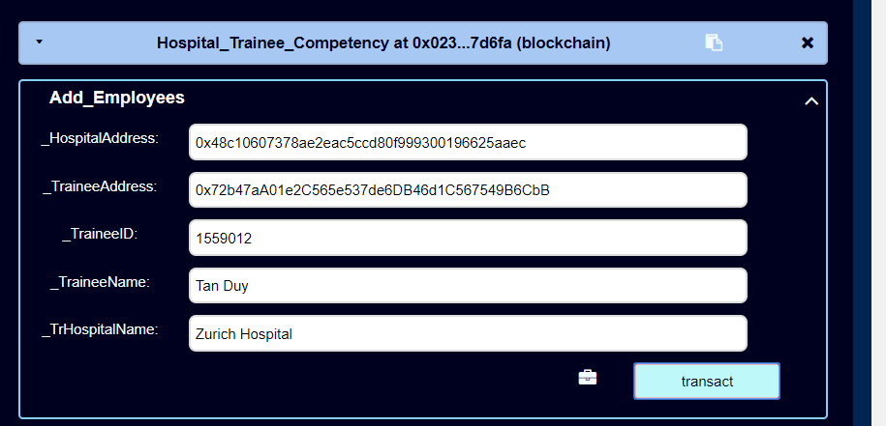

Same as authorizing hospitals, now you need to change to the authorized hospital address to add new employees to your hospital.

Fill in the information of the employee that you want to add. Then click on “transact” button.

Your filled-in information should look similar to the picture above.

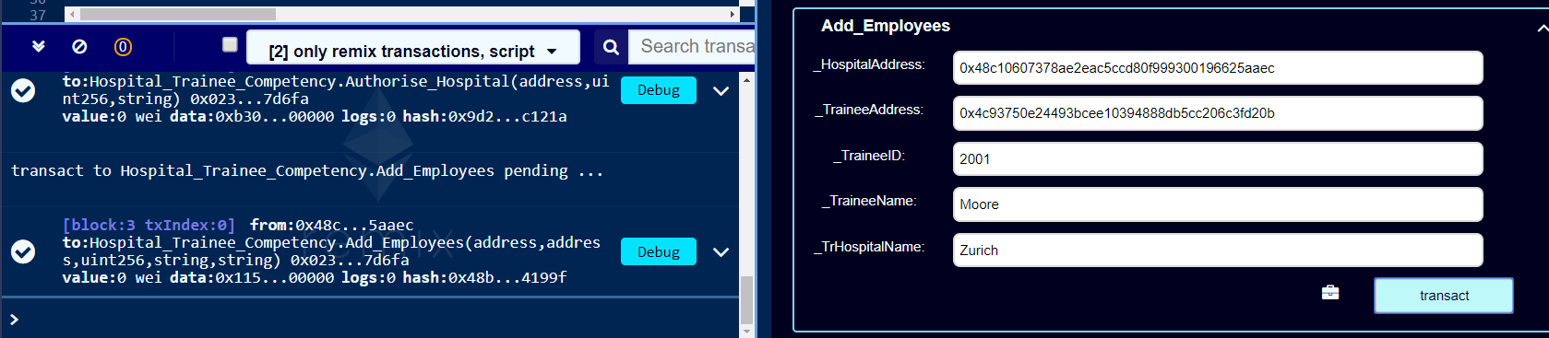

If it goes right, a new block will be created.



If this announcement pops up, it means you have failed to add a new employee. Check the input again as it requires.

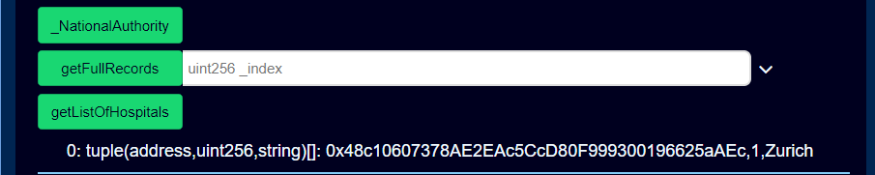

By now, you are able to see a list of authorized hospitals by clicking on “getListOfHospitals” button.

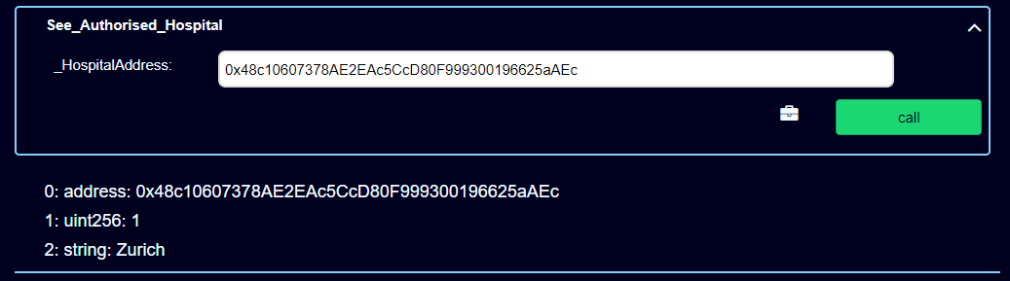

On the other hand, you can look up a specific hospital information by inputting that address at the “See_Authorised_Hospital” function. It will give you full information of that authorized hospital address.

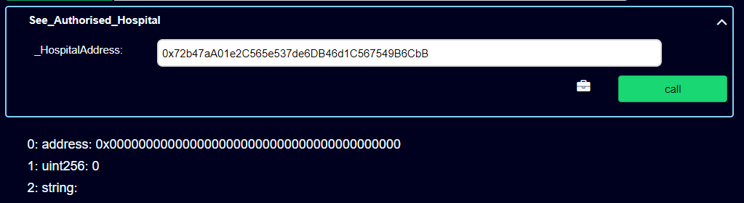

However, if it is not the authorized hospital address, it will show you nothing.

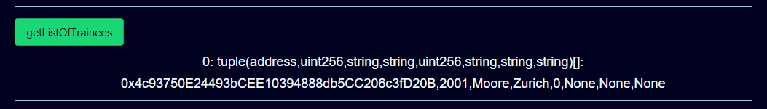

On “getListOfTrainees” function, you can see all the authorized employees information including their records.

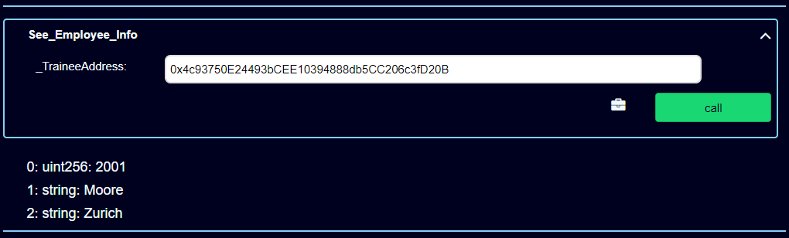

But you can see specific information of an address at “See_Employee_Info” function by inputting their address into “_TraineeAddress” field. It will show you the information of that employee.

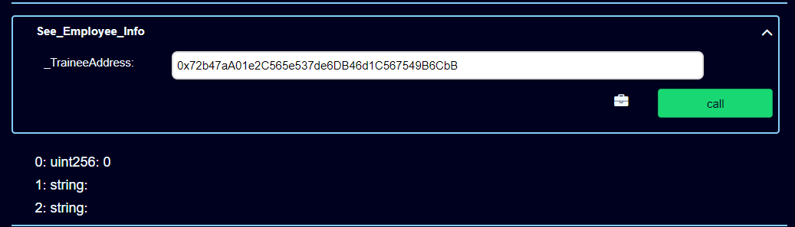

By contrast, if it is not an official employee address, it will show you nothing.



With “OfficialEmployees” function, you just need to input the index, it will give you the official employee address stored in Official Employee Storage.

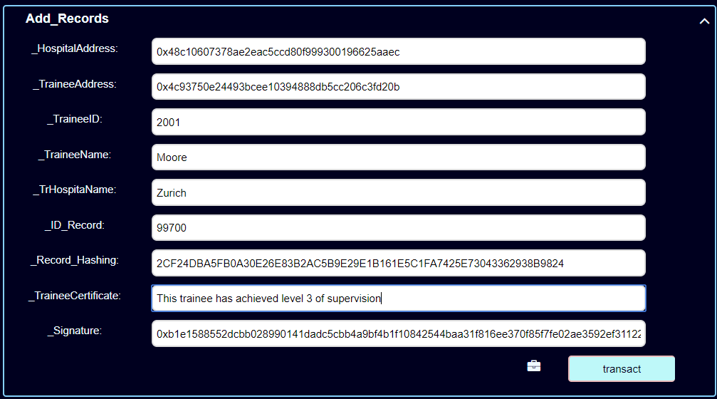Now, you can add new records for the official employee. Make sure when adding new records, the employee address has to match with the hospital they are working for.

Fill in required information to add new records for the employee as above. Note that, the information must be accurate or it will fail to add a new record. And click on “transact” button.

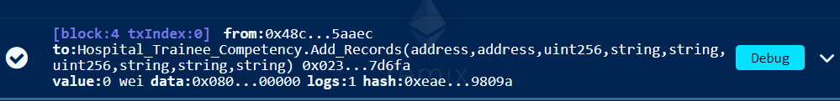

Once you add a new record successfully, it will create a new block on blockchain.



If this announcement pops up, it means you have failed to add a new record for that employee. Check the input again as it requires.

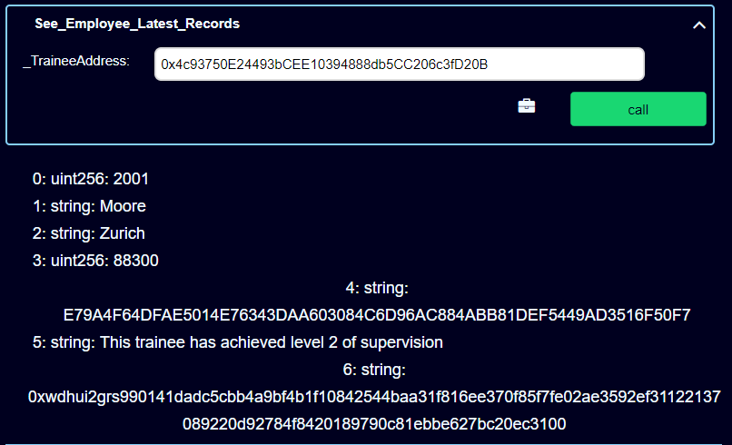

Now you can freely look up the latest record you have just created for that employee by their address. It will give you the employee information and employee’s record.

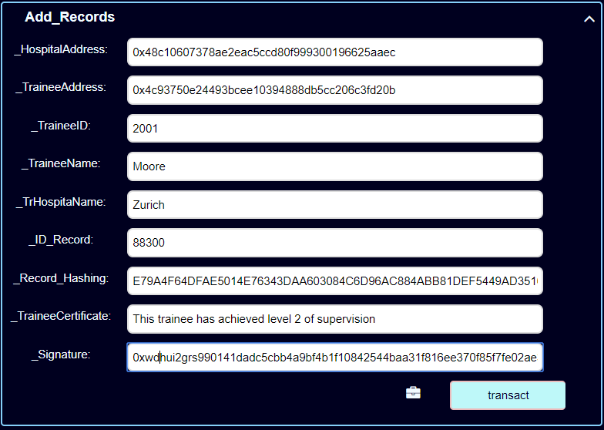

You can add many records as you want as long as it’s accurate and unique which means the ID of the record mustn’t be duplicated.

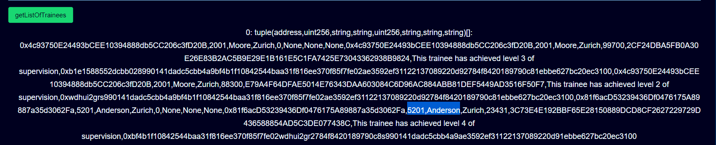  
At this point, I have added another employee to the hospital. And a new record for that employee.

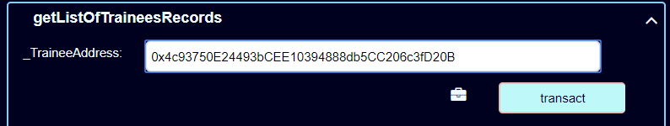

At this function, first you need to select and sort the records belonged to the specific employee so that you have a full list of records of that employee only. By having that, you input the address of that employee that you wish to see full records. And click on “transact” button.

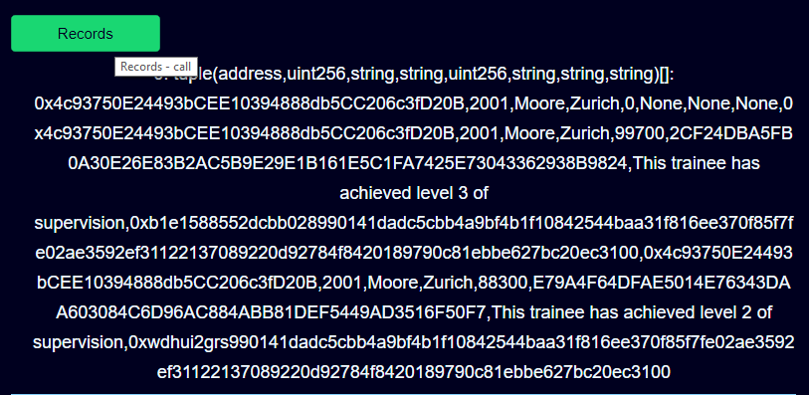

After that, you are able to see full records of that employee by click “Records” button. It gives you a whole list of that employee.

As you can see, there are only two records of that employee excluding Anderson’s record.

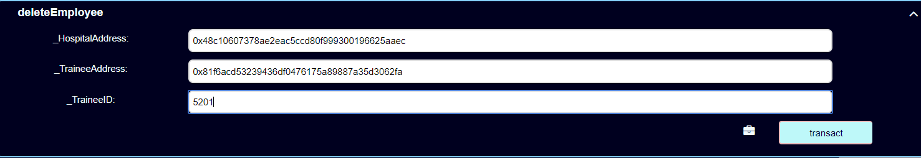

In a scenario that the employee doesn’t work for that hospital any longer, and moves to another hospital. You can delete that employee from your hospital by “DeleteEmployee” function.

With this function, it requires the hospital address, trainee address and its ID.

After filling the information, click on “transact” button.



If this announcement pops up, it means you have failed to delete that employee. Check the input again as it requires.

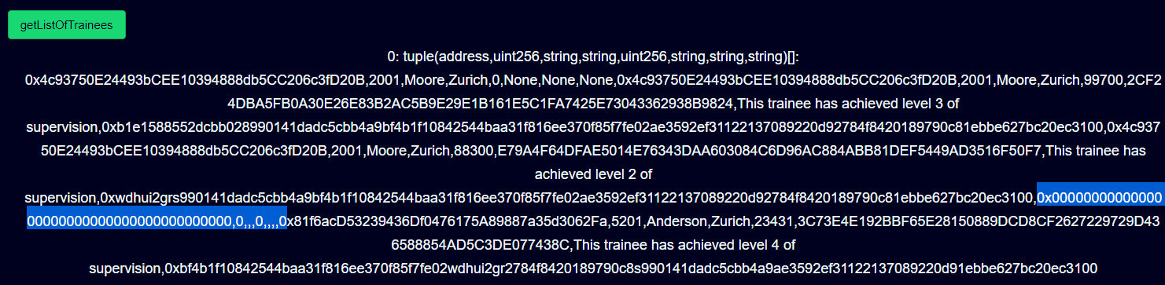  
If not, a new block will be created. And now you can check in the storage to see whether the employee still exists or not.

As can be seen, that employee address has been turned into “0x000000000000000000000000”. It means the employee has been deleted.

Note : the records of that employee still exists

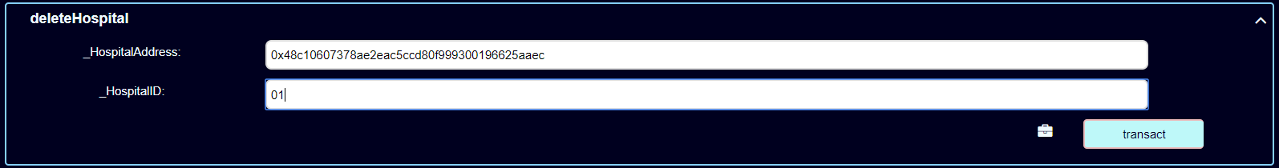

To delete authorized hospital, you need to log in as National Authority account. And input the hospital address and its ID. By deleting the hospital, it also deletes the employees’ addresses which referencing to the employees who are working for that hospital as well.

This function is discouraged to use. Be careful with this one.



If this announcement pops up, it means you have failed to delete the hospital. Check the input again as it requires.

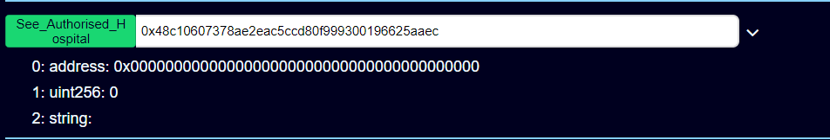

*Hospital Address 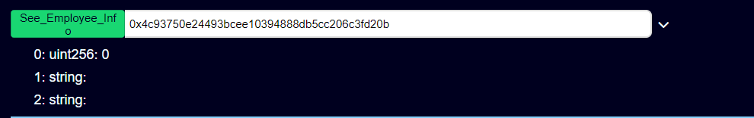

*Employee Address

If it is successful, a new block will be created. And from now on, you are not able to look up the information of hospital address as well as employees’ addresses working for that hospital.

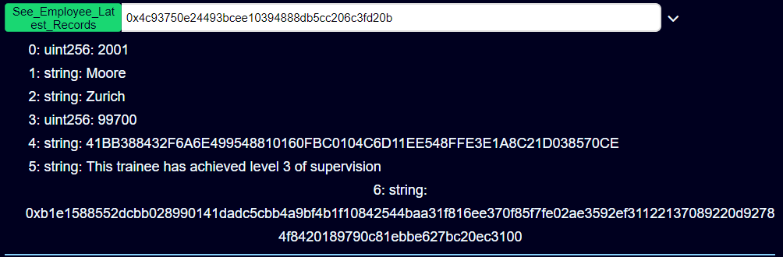

Now, the last function would be verify the Signature of the Certificate to see which is the address that signs the message. And later we can use that address to look up the information of that address.

As can be seen, number 5 and number 6 are the Certificate and Signature respectively.

At this function, first you need to have Web3 which used for hashing the Certificate.

You can install by following the instruction on this page <https://github.com/ethereum/wiki/wiki/JavaScript-API>

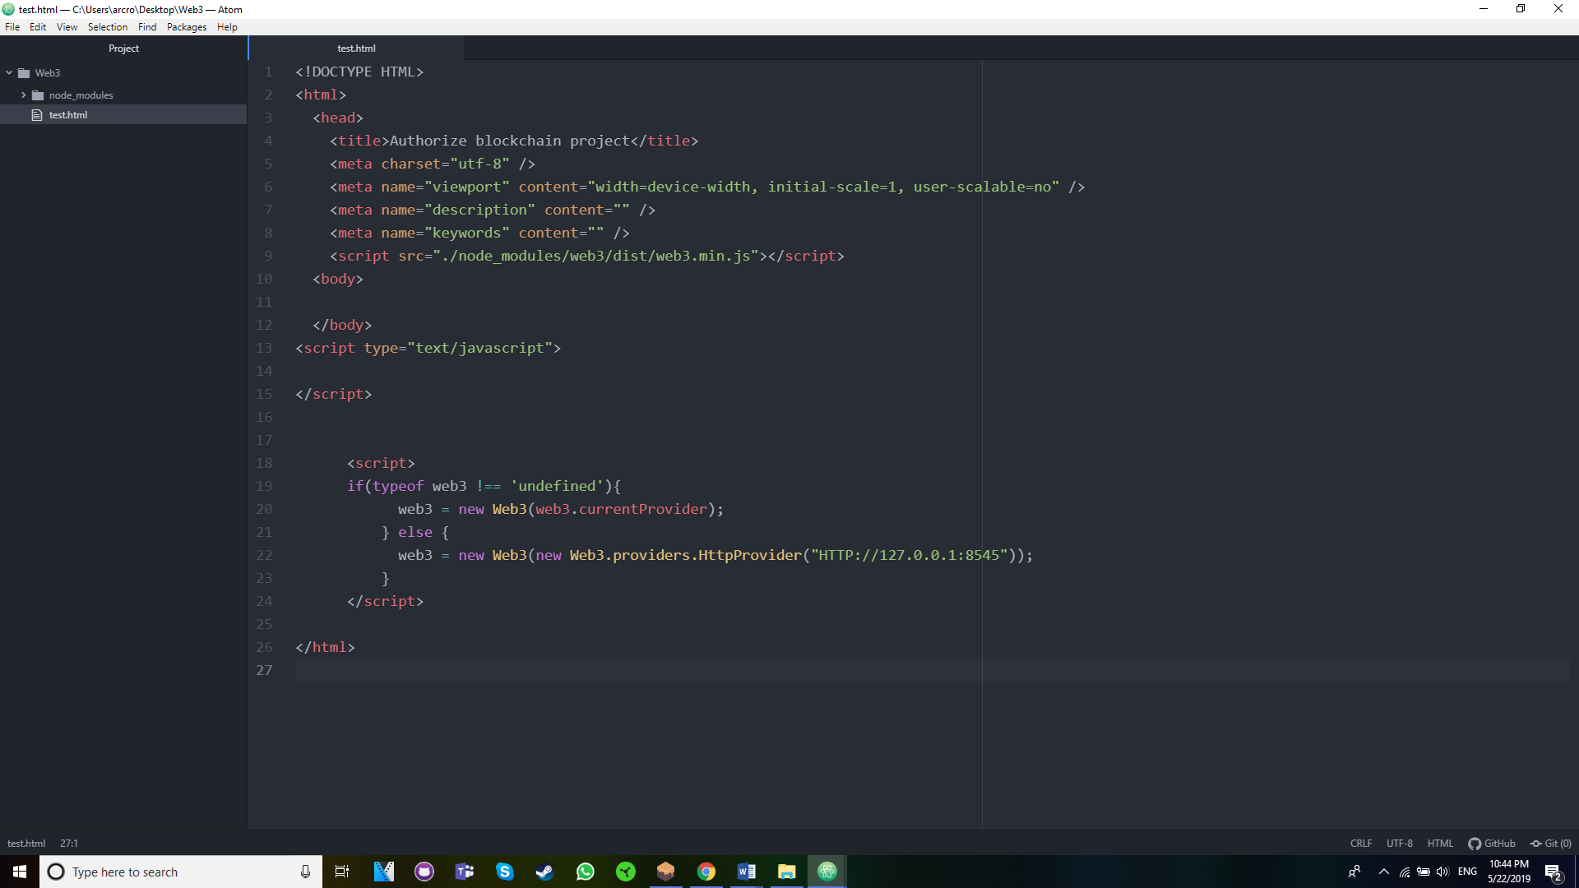

After finishing installing web3 into your computer, then navigate to your Web3 folder and create an HTML file following the <script> tag above.

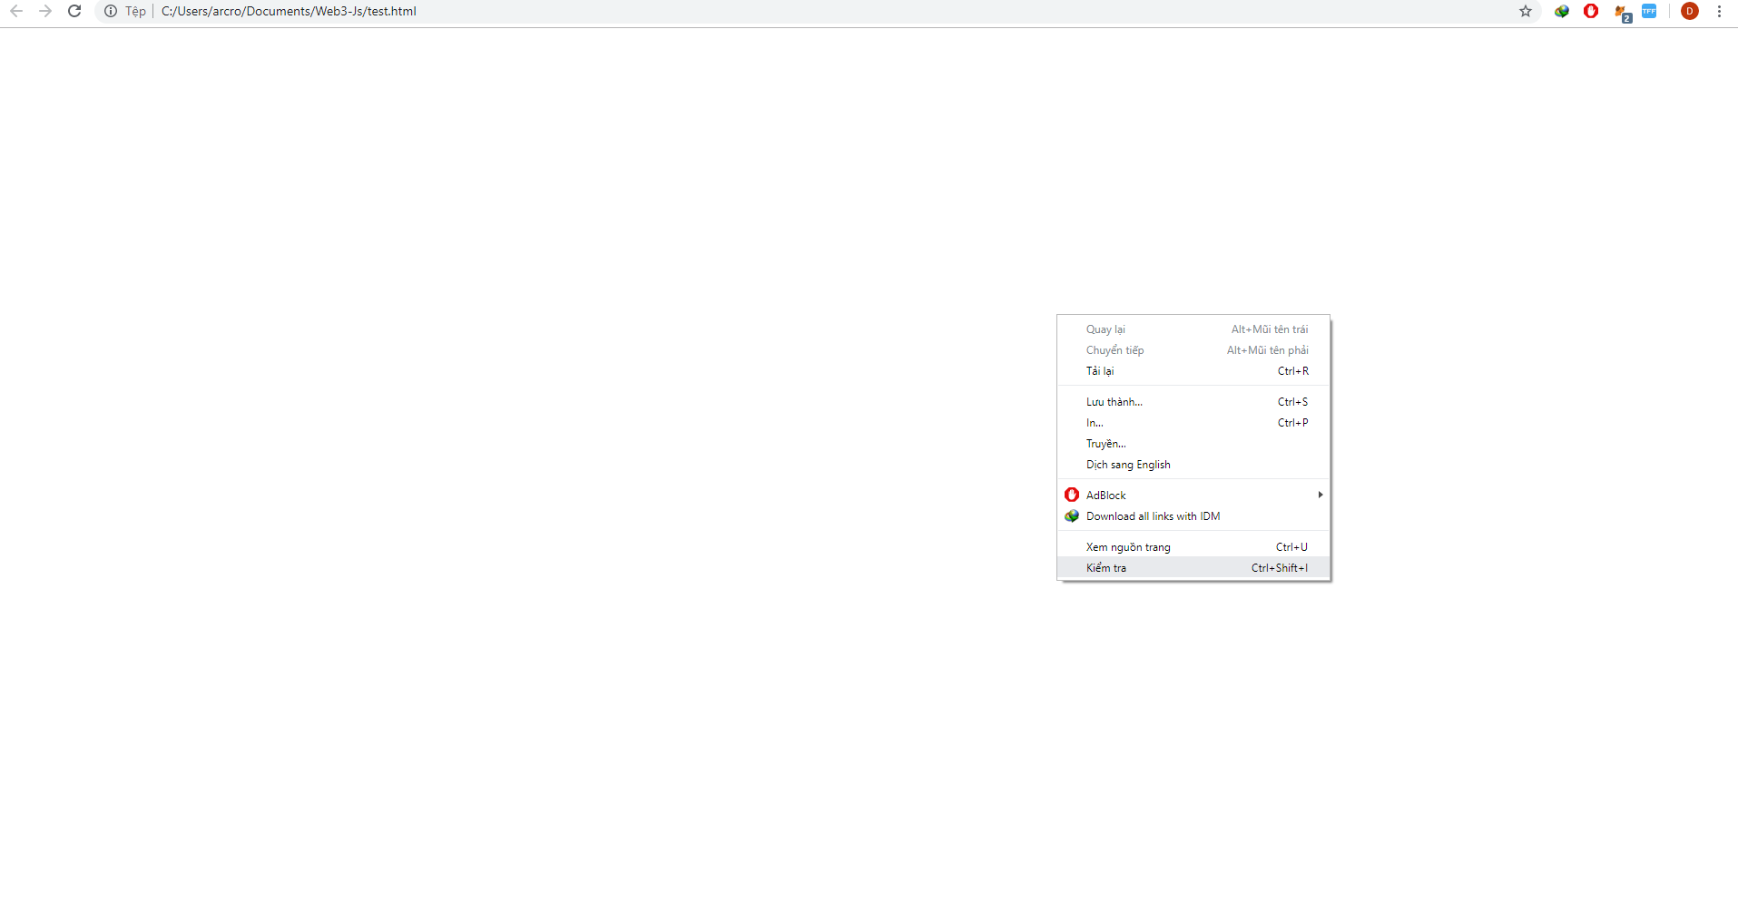

Then open the HTML file you have just created and right click to choose “Inspect” or “F12”

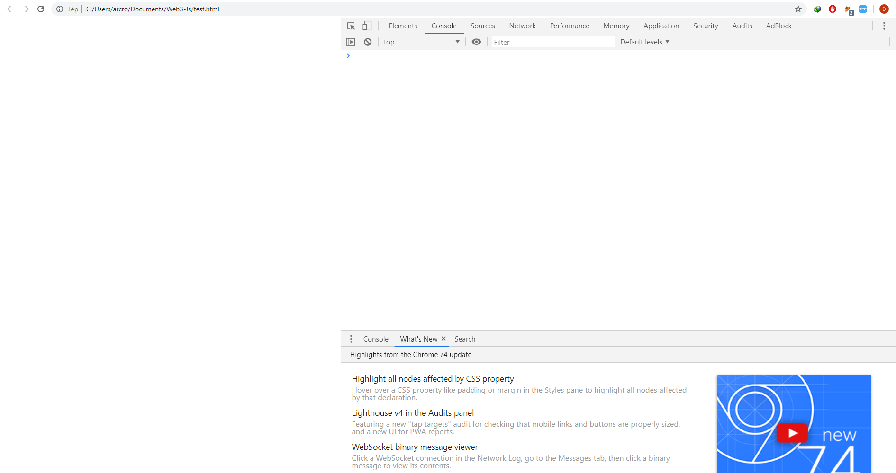

Move to “Console” tab and type as the following commands.

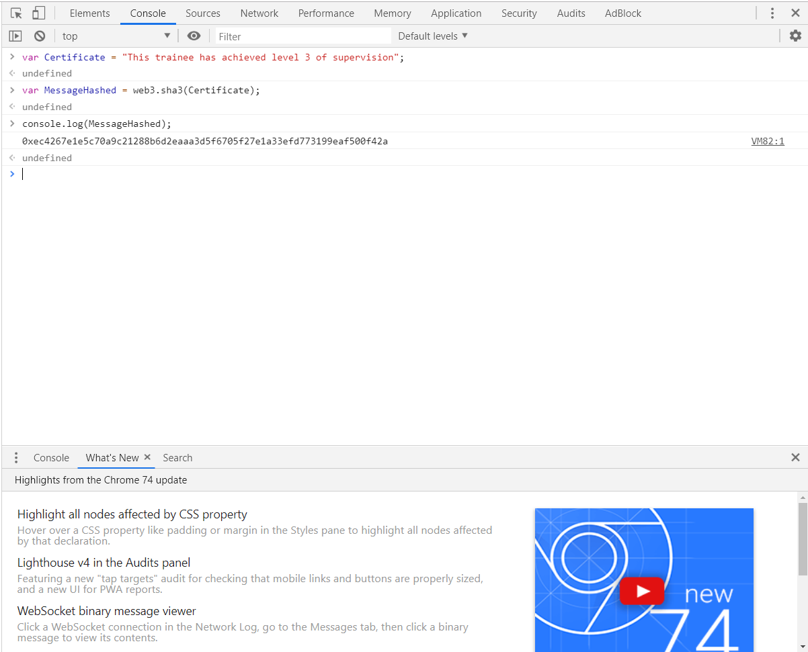

Note: the Certificate can be different depending on what the Certificate stored on Blockchain.

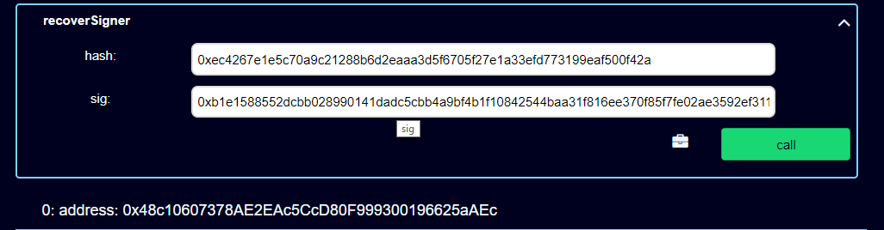

Copy and Paste hashing of the Certificate into “hash” field and its signature into “sig” field. And then click on “transact” button. It will show you the address of the signer which is also the address of the authorized hospital.